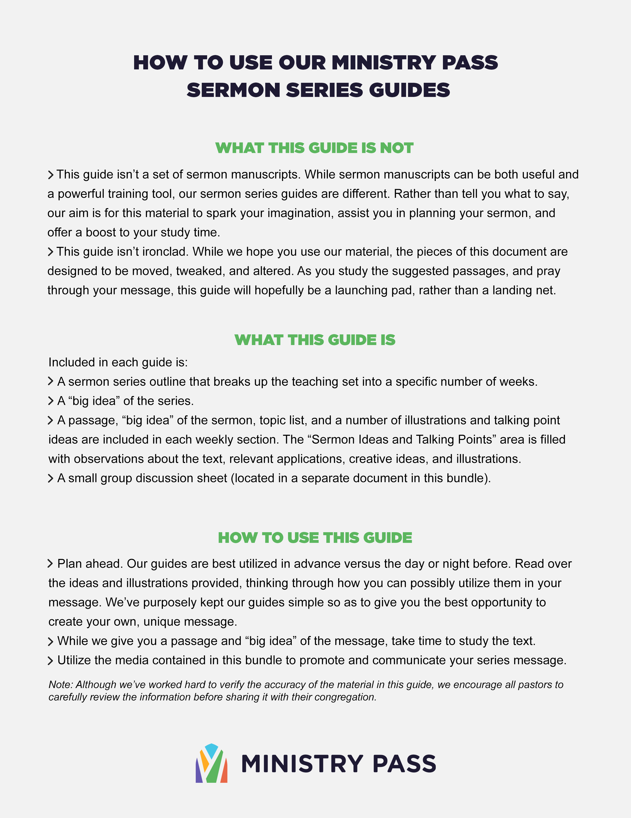

Scandal: The Scandal of the Cross

Big Idea of the Series: Scandal is a stand-alone sermon that would work well for a Good Friday service. In this sermon, we’ll look at the scandal of the cross and the paradoxical blessings that come from it.

Week 1
Text: Matthew 26:30–31
Topics: Crucifixion, Faithfulness, Scandal
Big Idea of the Message: The death of Christ is a scandal to the unbelieving world.
Application Point: Are you ashamed of Jesus’s death or inspired by it?

Sermon Ideas and Talking Points:

- David Wells doesn’t have an ordinary job. When his phone rings, it is not usually an ordinary call. That’s because David Wells is the fixer for the Dallas Cowboys. When a member of the Cowboys organization finds themselves in a situation that could reflect poorly on the organization, he is sent in to “fix” it. For example, in 2000 the receiver Michael Irvin was found in a bad situation, Wells raced to get there before the media and had Irvin give an impromptu press conference for the media as they showed up to cover the story. As the Washington Post article on Wells puts it: “The entire episode wound up being just as forgettable as Irvin’s words. And that was the point.” Why would the Dallas Cowboys have someone like Wells on retainer? Because the potential to avoid a scandal is worth the cost. Humans will do almost anything to avoid a scandal (Kent Babb, “When the Dallas Cowboys Have a Problem, This Is the Man Who Makes It Go Away” in Washington Post, September 30, 2016 https://www.washingtonpost.com/sports/redskins/when-the-dallas-cowboys-have-a-problem-this-is-the-man-who-makes-it-go-away/2016/09/30/a7bdeaf0-84e8-11e6-92c2-14b64f3d453f_story.html). Today we will look at the death of Jesus by crucifixion and see that God intentionally chose a scandalous way to die for our sins.
- In the Roman world that God entered in human form, crucifixion was the most insulting way to die. As classical historian Tom Holland writes, “No death was more excruciating, more contemptible, than crucifixion.” Roman intellectuals were in agreement that it was the worst way to die, which is “what rendered it so suitable a punishment for slaves” (Tom Holland, Dominion [New York: Hachette Book Group, 2019], 2). Naturally, for the contemporaries of Jesus and a good many of his followers, it was a significant obstacle to faith that Jesus was killed by the shameful death of crucifixion. It wasn’t just that the Romans despised crucifixion, but for Jews it was also a cursed way to die (Deuteronomy 21:23; Galatians 3:13).
- But here’s the remarkable thing: Jesus knew his death was scandalous. And on the night he was betrayed, he challenged his believers by telling them the scandal would drive them away. In Matthew 26:31, Jesus said, “You will all fall away because of me this night. For it is written, ‘I will strike the shepherd, and the sheep of the flock will be scattered.’” The Greek word that is translated “fall away” in the ESV is skandalizō. Its root is skandalon, which is the basis for our modern word scandal (Strong’s Greek Lexicon, s.v. “G4624, skandalizō, https://www.blueletterbible.org/lang/lexicon/lexicon.cfm?Strongs=G4624&t=KJV).Jesus didn’t shy away from the coming scandal; in fact, he embraced it.
- After hearing this, Peter responds, “Though they all [are scandalized] because of you, I will never [be scandalized]” (26:33). It is a bold declaration: “No matter how shocking things may get, I will never be ashamed to stand by you.” Unfortunately, Peter’s actions did not match up with his words, and later that very night he denied even knowing Jesus multiple times (Matthew 26:69–75). It’s so easy to say, “I’m not embarrassed by the good news; I’m not ashamed to say I’m a Christian”—but when push comes to shove, do you scatter and deny Jesus, or do you stand by him?
- After Peter’s denial, Jesus experienced the terrible pain and humiliation of the cross. Death by crucifixion was so painful that it’s where we get the word excruciating (Online Etymology Dictionary, s.v. “excruciate,” https://www.etymonline.com/word/excruciate).
- Jesus embraced the scandal of the cross because it was necessary that he die the death of an obedient servant (Philippians 2:8). The wrath of God had to be satisfied for our sins, and the love of God in Christ stepped into that gap, hung on the cross, and saved us from our sins. And so we are called to embrace the scandal of the cross as well! The world doesn’t understand the concept of sin, and it doesn’t understand the thought that God could die the death of a criminal. Nevertheless, what the world considers scandalous is the message we must preach. This is why Paul encouraged the believers in Corinth with the words, “But we preach Christ crucified, a stumbling block [skandalon] to Jews and folly to Gentiles (1 Corinthians 1:23). But however the world sees this message, those of us who believe understand it to be “the power of God and the wisdom of God” (v. 24).

Unless otherwise indicated, all Scripture quotations are from The Holy Bible, English Standard Version® (ESV®), copyright © 2001 by Crossway, a publishing ministry of Good News Publishers. Used by permission. All rights reserved.

At the time of publication, we check that URLs are working but are not able to guarantee that third-party sites we link to will remain active.

